Course End Project Report
Slack Integration with Jenkins for Automated CI/CD Deployment

Submitted By
Name: Swapnil Sonawane
Project Title: Slack Integration with Jenkins for Automated Build, Deployment and Notification System

Environment Details:

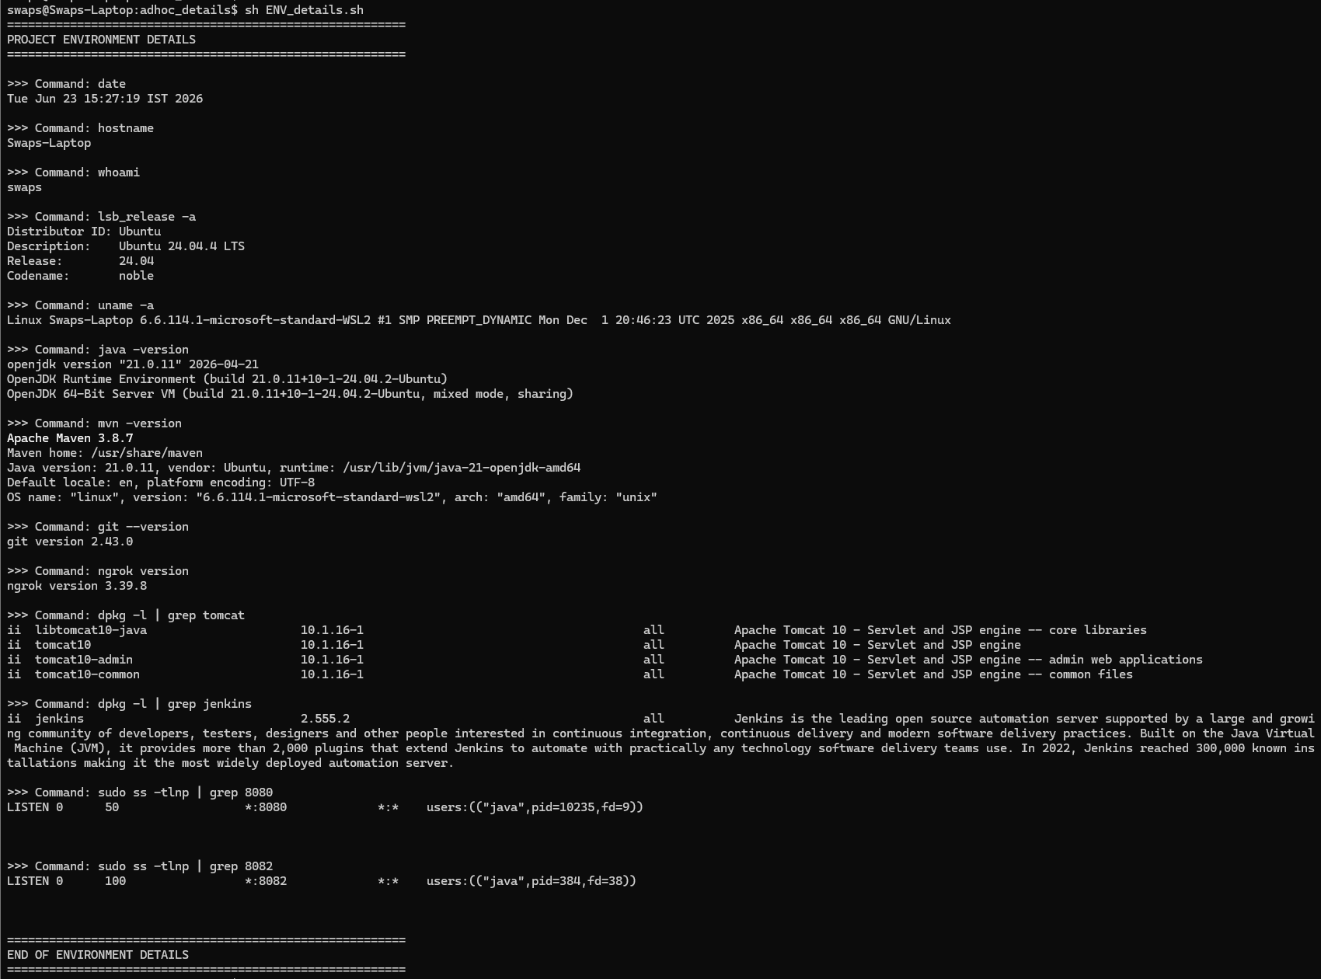

Figure 1: Slack Channel Creation
Description:
Dedicated Slack channel created for build notifications.
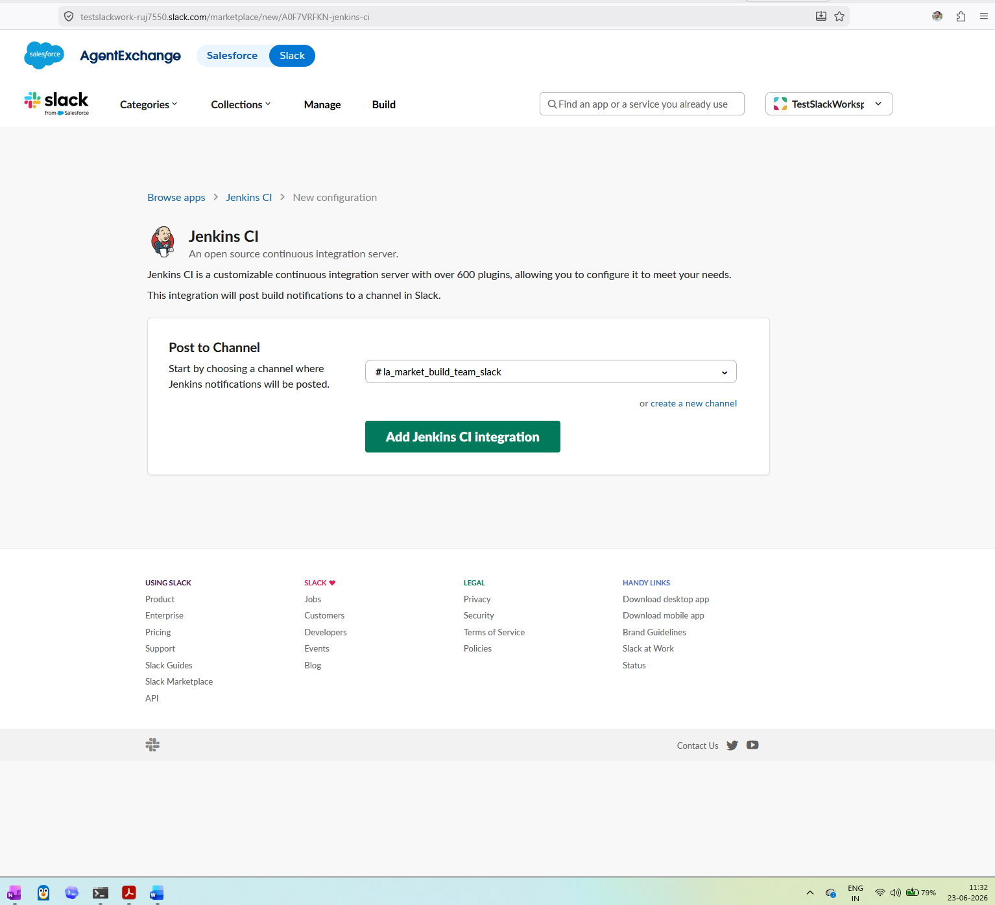

Figure 2: Slack Notification Plugin Installation
Description:
Slack Notification Plugin installed in Jenkins.
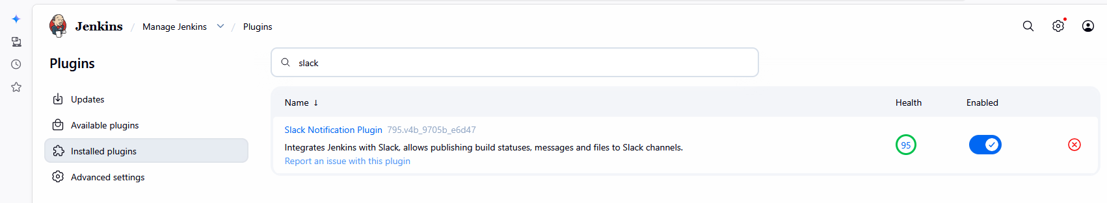

Figure 3: Slack Configuration in Jenkins
Description:
Slack workspace integrated with Jenkins.
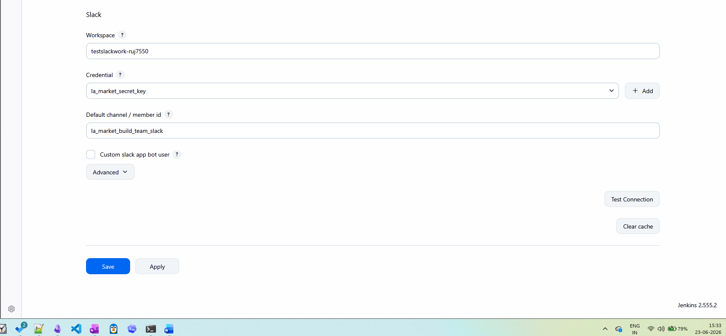

Figure 4: Jenkins Freestyle Project
Description:
Creation of La_Market_Deployment_Pipeline job.
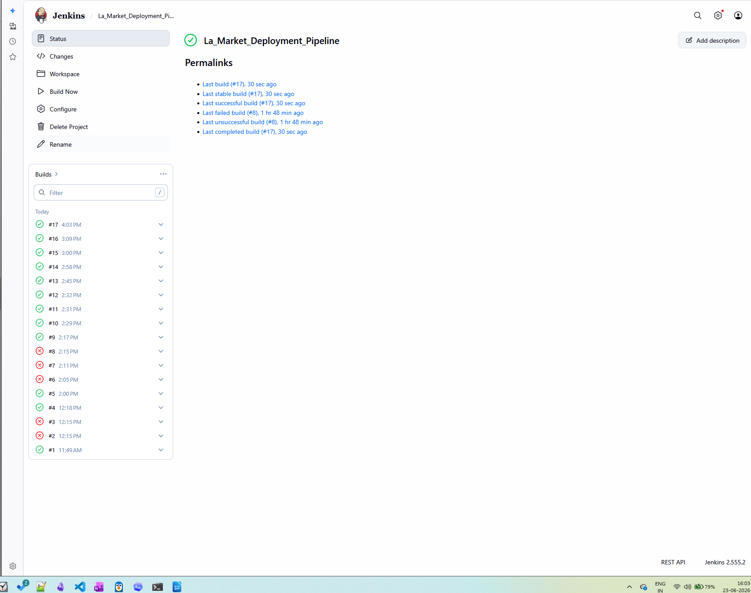

Figure 5: GitHub Repository
Description:
GitHub repository containing Maven application source code.
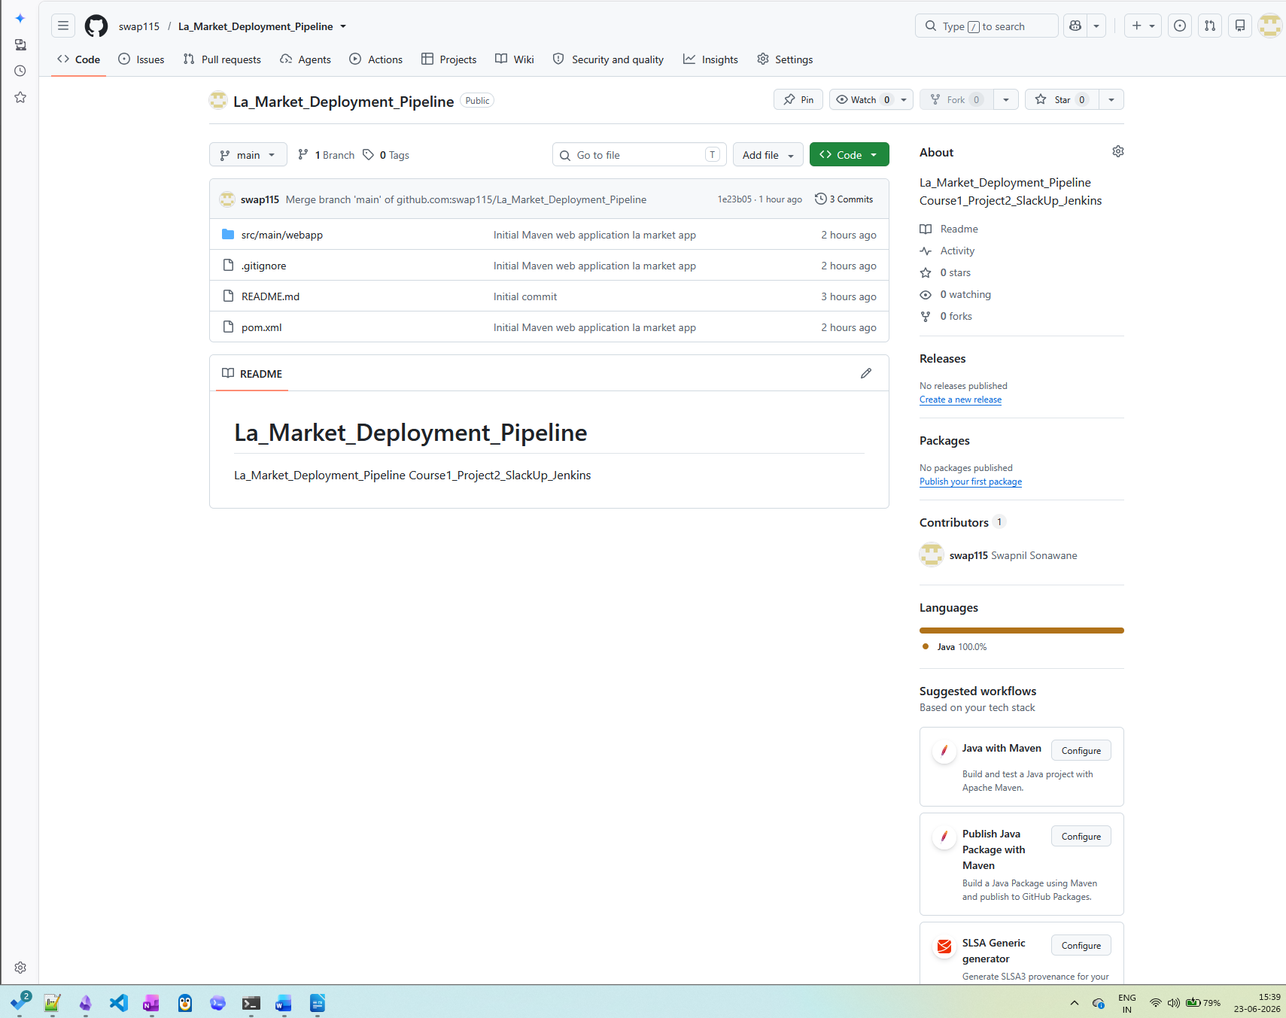

Figure 6: Jenkins SCM Configuration
Description:
Git repository and branch configuration.
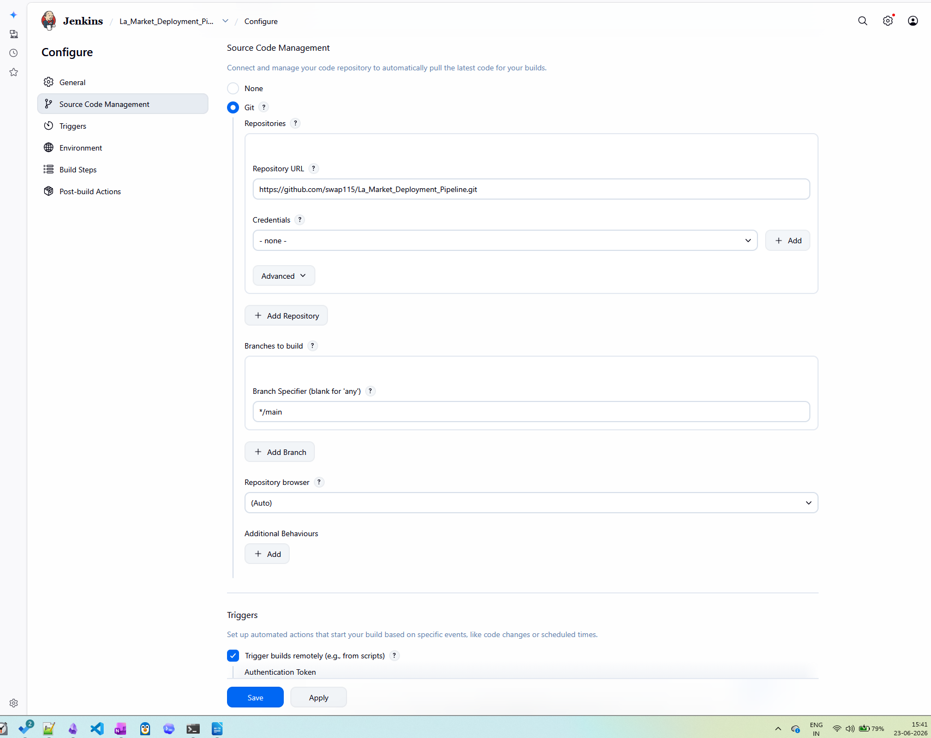

Figure 7: Maven Build Configuration
Description:
Maven goal configured as clean package.
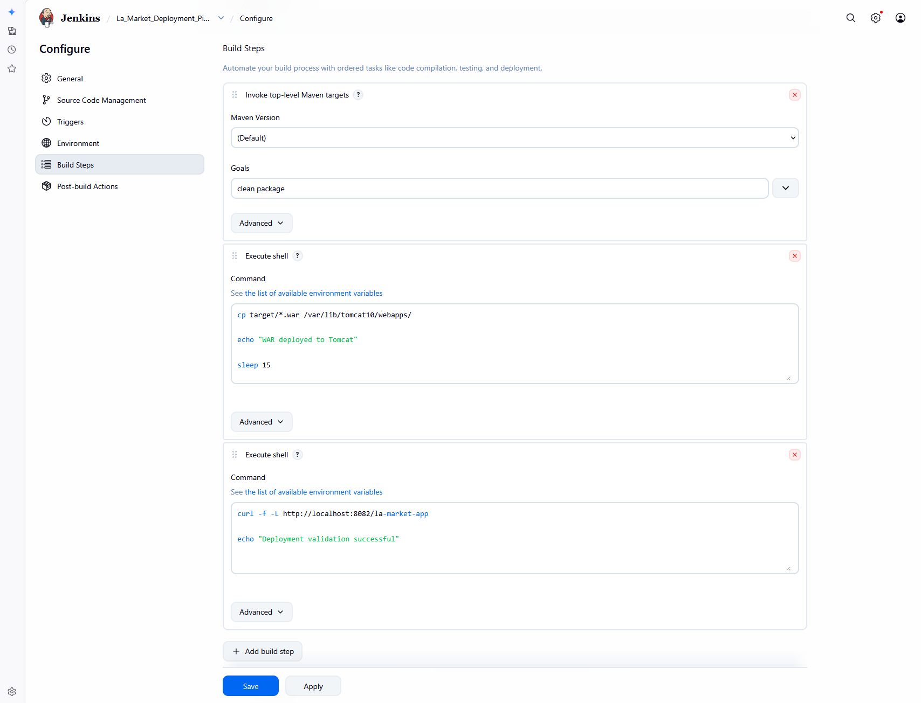

Figure 8: Maven Build Success
Description:
Successful build and WAR generation.

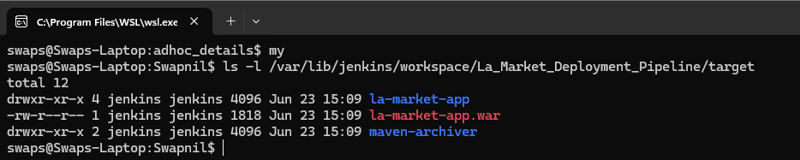

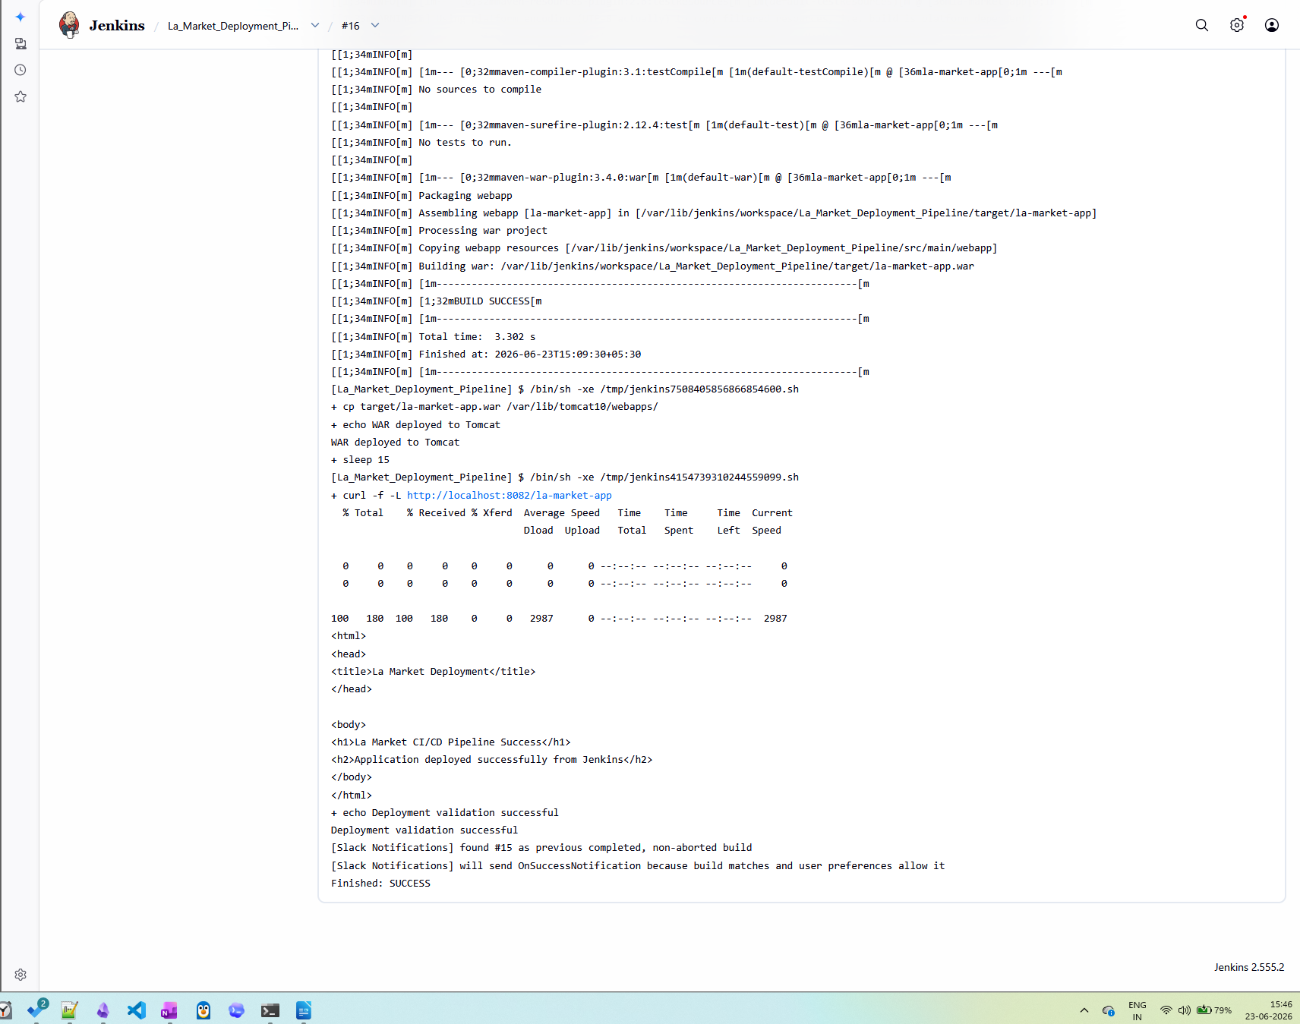

Figure 9: Tomcat Application Running
Description:
Application successfully deployed on Tomcat port 8082.
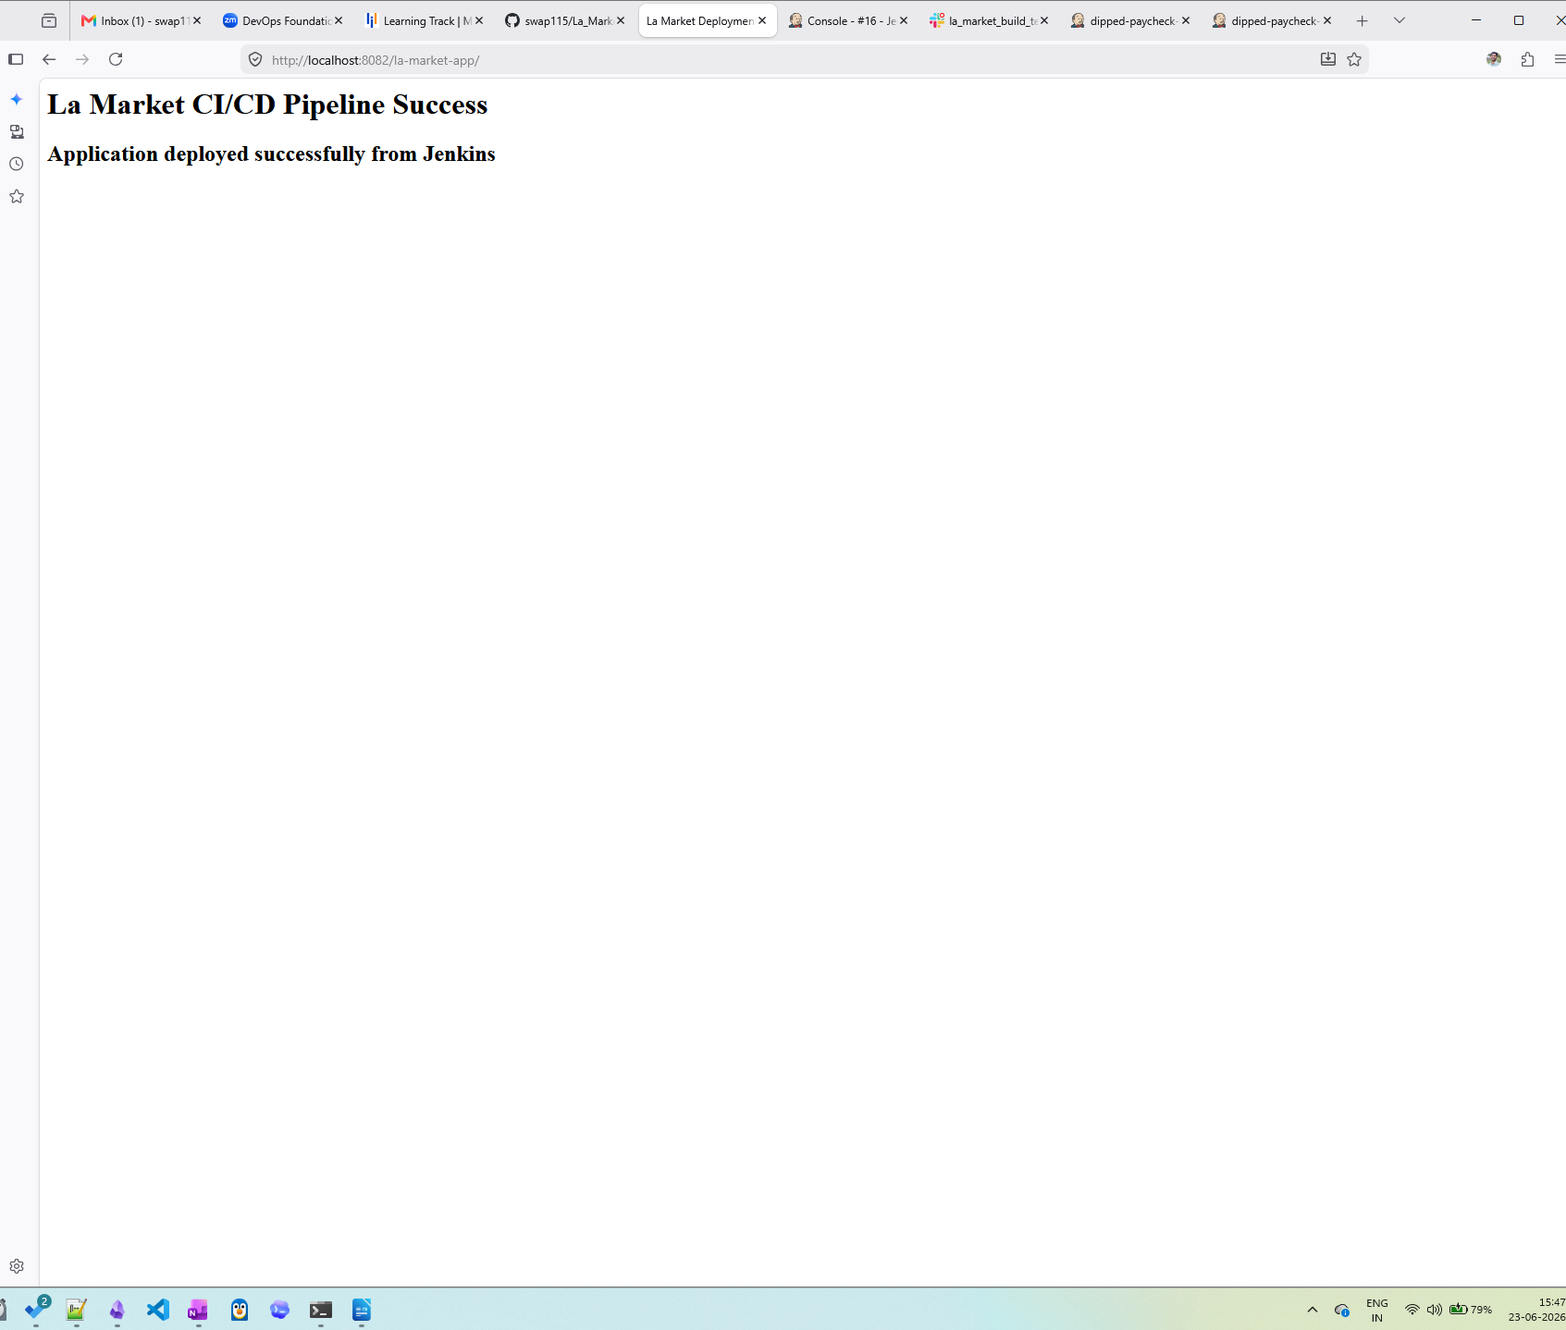

Figure 10: Automated Deployment Configuration
Description:
Execute Shell deployment step.


Figure 11: Application Validation
Description:
Health check validation after deployment.


Figure 12: Slack Build Notification
Description:
Build success notification sent to Slack channel.
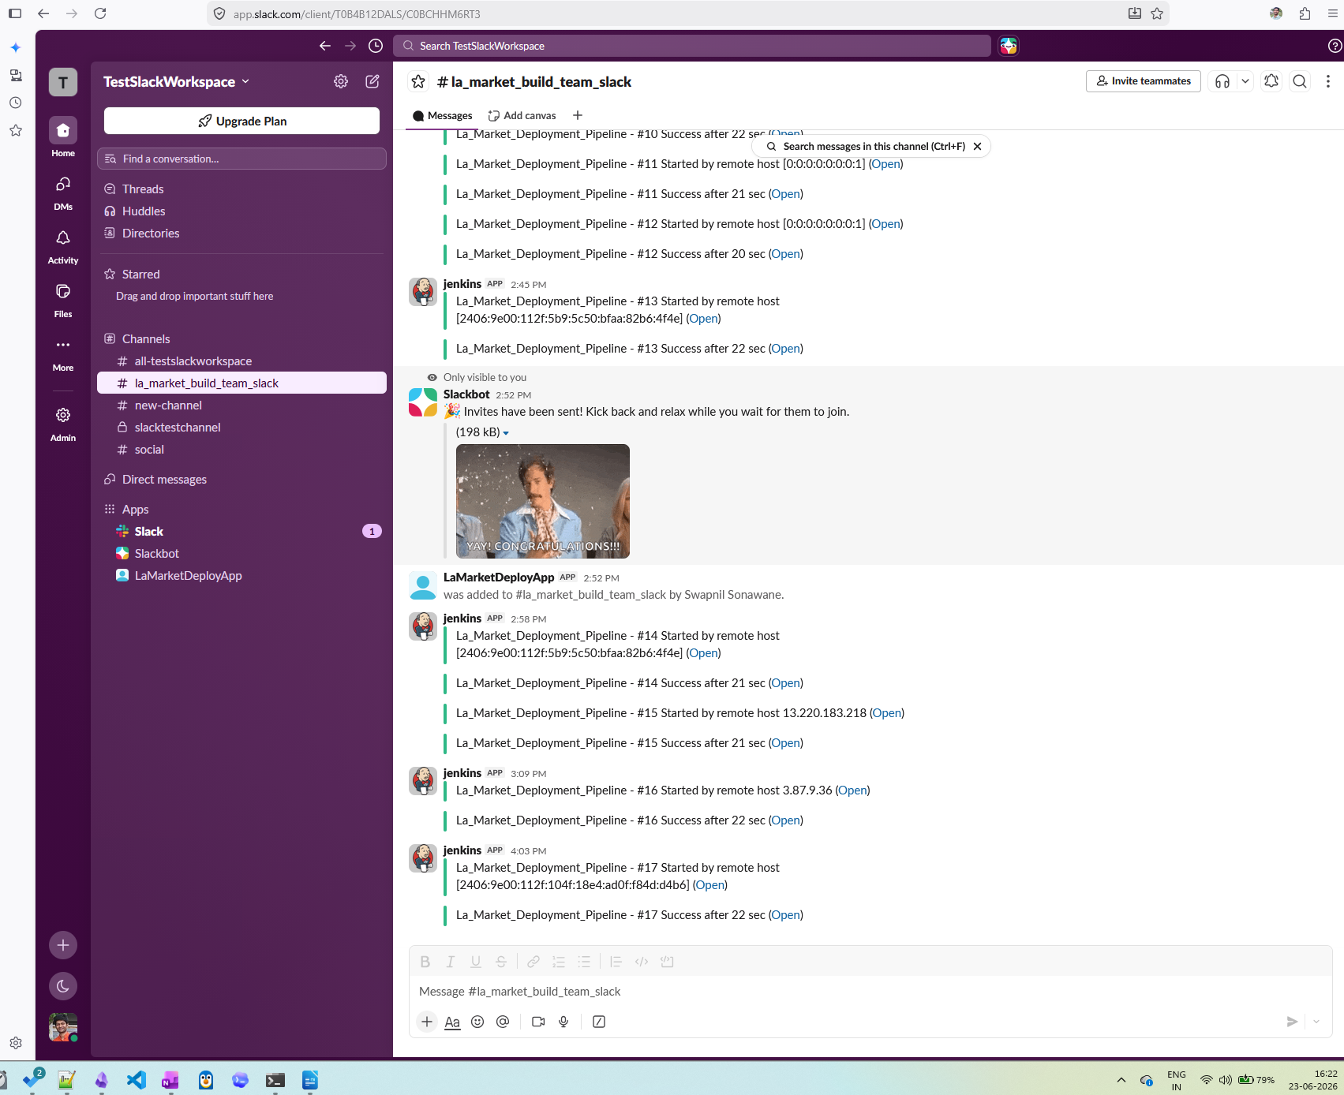

Figure 13: Remote Build Trigger
Description:
Jenkins remote trigger token configuration.
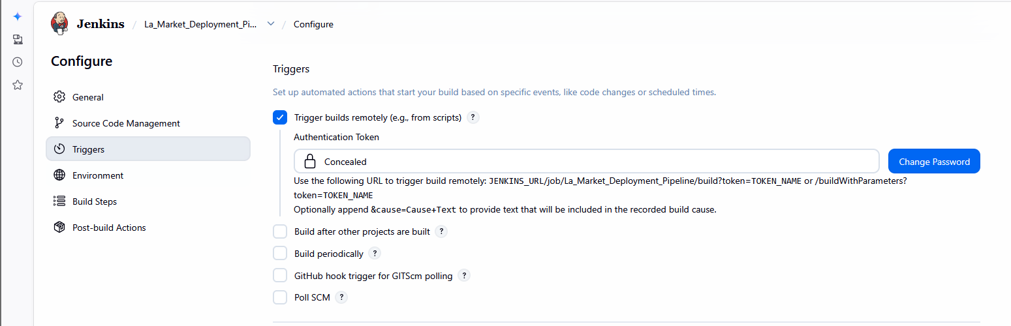

Figure 14: ngrok Tunnel
Description:
Public endpoint exposing Jenkins.
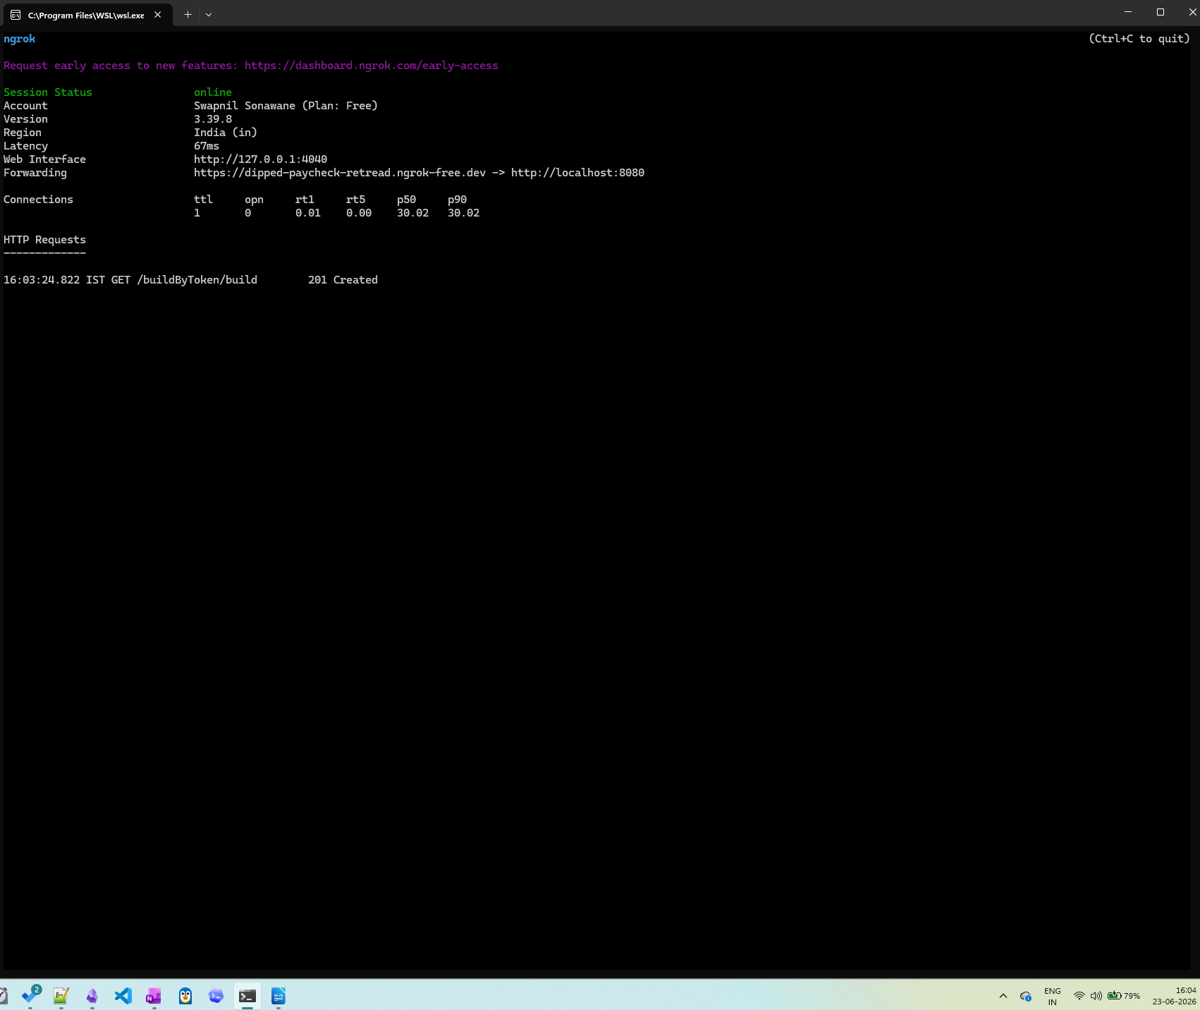

Figure 15: Slack App Creation
Description:
LaMarketDeployApp created for slash command support.
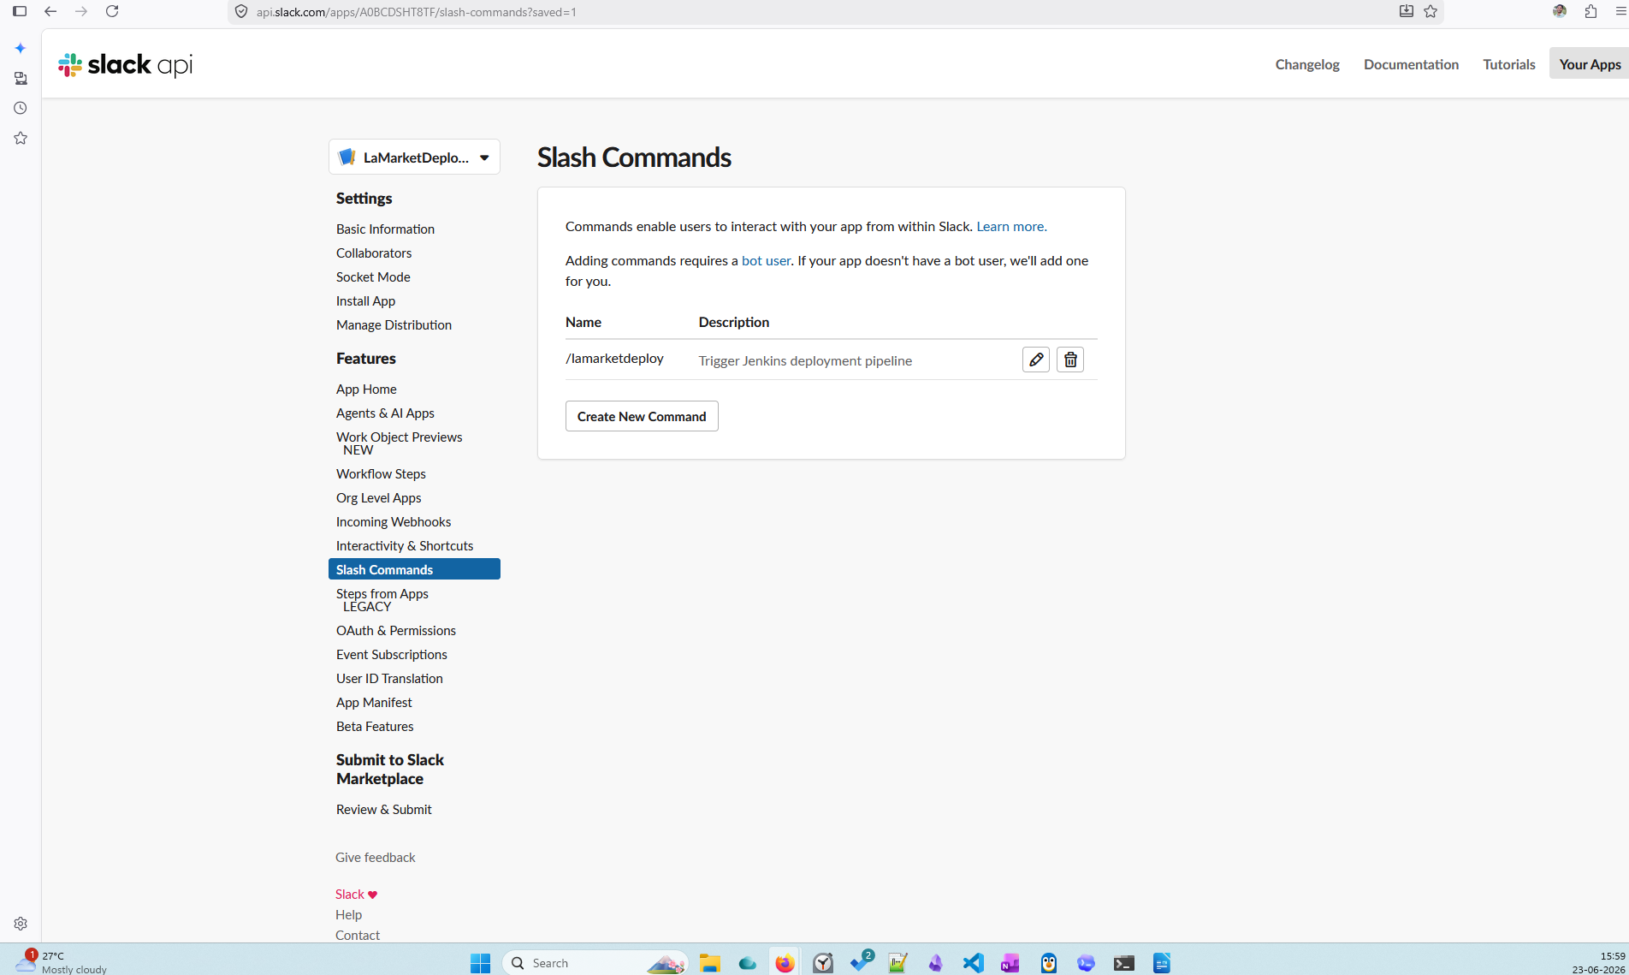

Figure 16: Slash Command Configuration
Description:
Configuration of /lamarketdeploy command.
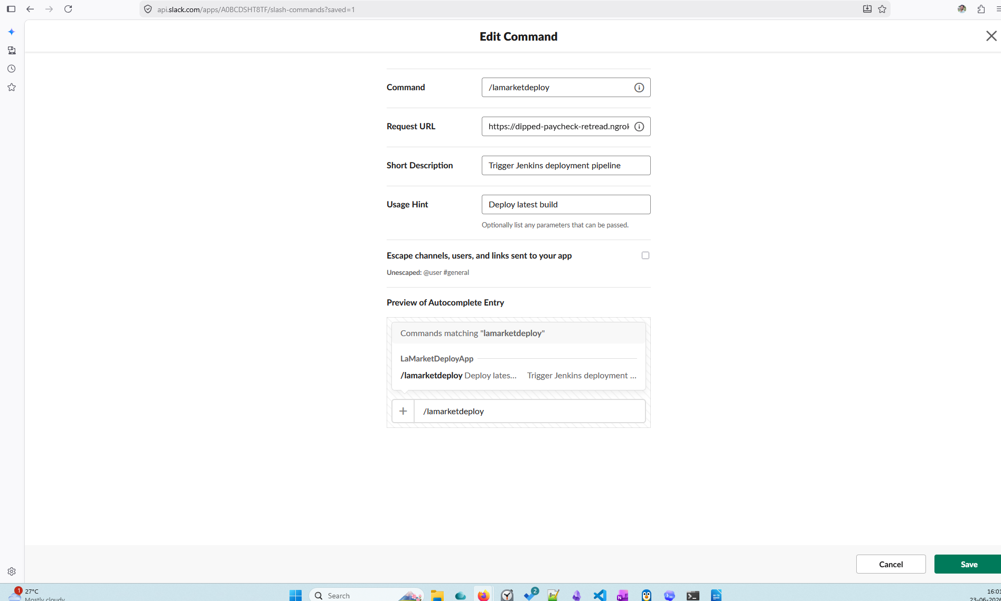

Figure 17: Jenkins Build Triggered via Slack
Description:
Slash command successfully invoked Jenkins build.


Figure 18: End-to-End Success Flow
Description:
GitHub → Jenkins → Maven → Tomcat → Slack.


